Bug Life cycle

**What is Bug Life Cycle?**

Bug Life cycle is the journey of a defect cycle, which a defect goes through during its lifetime. It varies from organization to organization and also from project to project as it is governed by the software testing process and also depends upon the tools used. Some bug reporting/tracking tools are: Assembla, JIRA, Bugzilla, Mantis etc.

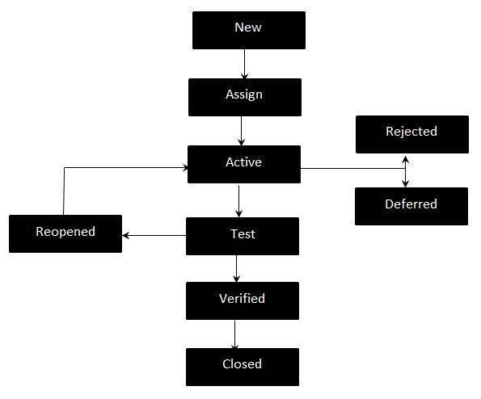

## Bug Life Cycle States:

* **New -**When a new defect is logged and posted for the first time. It is assigned a status NEW.
* **Assigned -**Once the bug is posted by the tester, the lead of the tester approves the bug and assigns the bug to developer team.
* **Active -**The Defect is being addressed by the developer and investigation is under progress. At this stage there is two possible outcomes; - Deferred or Rejected.
* **Test/ Fixed -**The Defect is fixed and ready for testing.
* **Verified -**The Defect that is retested and the test has been verified by QA.
* **Closed -**The final state of the defect that can be closed after the QA retesting or can be closed if the defect is duplicate or considered as NOT a defect.
* **Reopened -**When the defect is NOT fixed, QA reopens/reactivates the defect.
* **Deferred -**When a defect cannot be addressed in that particular cycle it is deferred to future release.
* **Rejected -**A defect can be rejected for any of the 3 reasons; viz - duplicate defect, NOT a Defect, Non Reproducible.

**Bug Report**

After uncovering a defect (bug), testers generate a formal defect report. The purpose of a defect report is to state the problem as clearly as possible so that developers can replicate the defect easily and fix it.

**What are the goals of a bug report?**

* The fix should be faster so that the software becomes bug free
* The report should clearly describe the problem to the programmer so that the root cause can be identified specifically.
* It should enable programmers to see the program failing in front of them.

**Bug Report Template**

In most companies, a defect reporting tool is used and the elements of a report can vary. However, in general, a defect report can consist of the following elements.

**Bug No :** The bug number of the tracking system  
**Link :** It is the public/private link of the bug  
**Bug Title :** A title should describe the bug’s key point.(one line max)  
**Bug Summary :** A summary should describe the full bug at a single line( Should not exceed one line)  
**State :**  Any one of the bug states.( detail about those states in different post)  New/Open/Assign/Test/Verified/Deferred/Reopened/Duplicate/Rejected /Closed  
**Prerequisites:** The pre installed items/requirements should be here.

* Name of operating system (if it has dependency on different OS)
* Name of software installed (if it has dependency on software, Ex- Dot Net framework)
* Name of browser (if it has dependency on browser.  Ex- Firefox, chrome, safari.)
* Name of proxy (it it has decencies on environment. Ex- NTLM, Authenticate Proxy etc)
* Hardware conditions & configurations (it it has dependency on different hardware)

**Bug found version:** The version no of the software in which the bug was founded  
**Bug fixing version:** This is an optional tag describing which version will get the solve of the bug( following project’s release plan)  
**Severity:** The bug’s priority should be here. These are some priority tags (from wiki). Those may be change due to project scope. You may add priority value in there.

* Blocker – blocks development and/or testing work (you probably wouldn't know)
* Critical – crashes, loss of data (internally, not, say, your edit preview)
* Major – major loss of function
* Minor – minor loss of function or other problem where easy workaround is present
* Trivial – cosmetic problem like misspelled words or misaligned text
* Enhancement – request for enhancement (feature requests)

**Reproducing steps:** These are steps to reproduce the bug. Every steps should be distinct. In here a good tester will provide the shortest path to reproduce the bug.   
Actual Value : The facts that found following the steps  
Expected value :The results that was expected following the steps. It will be perfect to link up the expected results with SRS/FRC documents.   
**Assign To:** The responsible person who will take care of the bug.(initially, It may be assigned to team leads, they may distribute the responsibility)  
Reported by : Bug reporter's name    
**Comments:**  Comments which are very much welcomed in a bug life cycle. Any member or the responsible person can comments on that. It can be use for describing current state of the bug in development lifecycle.   
**Attachments:** Most of the bug trackers supports multimedia attachments. If necessary, you may attaché pictures, audio or even video. The best practice is to attaché picture (screen shots).

**An Example of the Good Bug Report**

Let's think a web application www.testWebApp.comhas a log in page. A tester have found a bug that an user named Shantonu, password: 123456 can’t log in using Firefox browser (3.6.15) under Windows XP with Authenticate proxy conditions. Now, how he will report this bug using following template.

(Suppose that bug is not listed before)

**Bug Report**

**Bug No:**

1 (mostly, the reporting bug tracker will provide the value, no need to insert)

**Bug Link:**

mostly, the reporting bug tracker will provide the link which may public or private

**Bug Title:**

Failed to log In

**Summary:**

User: Suvro, Password:123456 can’t login with Firefox 3.6.15

**State :**

New as newly posted

**Prerequisites:**

Please make sure that the following environment is set   
-Windows XP professional 5.1.2600 Service Pack 3 Build 2600  
-Firefox 3.6.15 is installed (cache cleaned)   
-Authenticate proxy is installed

**Bug found version:**

0.0.5.125

**Severity:**

Blocker [as it is un useable on that conditions] (it may be major if the release priority is

not on proxy/browser) 17 [IV value following UTP method, describe in different post]

**Reproducing steps:**

1. While running pc at windows, run Firefox 3.6.15 from start menu.   
2. After opening, write the address (www.suvroapps.com) in the address bar & press enter  
3.When login page appears, insert the user name as suvro and password as 123456   
4.Wait & see that Failed to Login (or http bad request)

**Actual Value:**

The login fail. (or HTTP bad requested)

[it is better to provide a **screen shot** and the error details here]

**Expected value:**

User suvro should successfully login

[you may add the specific FRS/SRS reference for better understanding]

**Assign To:**

Mr. Jamal (as team lead or selected reported person or responsible person)

**Reported by:**

Mr. Kamal

**Comments:**

**Attachments:**

Screenshot1: Failed state [the attached screenshot]

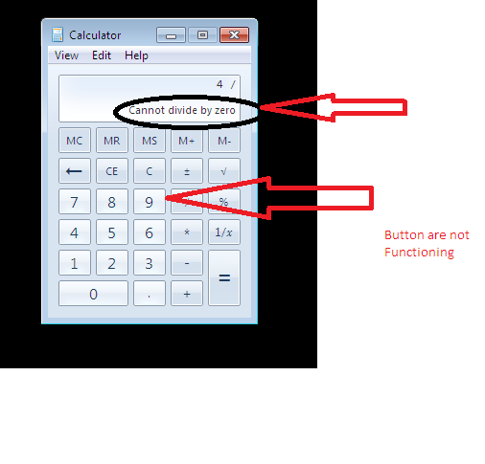

Before report a bug, it would be nice if you take care of the following terms

**Be specific:** Be very much specific for the steps and all the sections.

**Be descriptive:**  Provide more detail information rather than less. But be careful as If you say too much, the developer can skip some and if you say too short they have to come back and ask more questions. Ex- At the starting of my career, I wrote some bugs with one line steps where I had to explain several time to the developer. Later on I had to provide more detail on the comment section. So, bottom line is , you have to be descriptive enough to make all understand about the problem and you have to avoid over description.

**Be careful of pronouns & language:** Be specific on component like don’t use words like "it", or references like "the window", when it's unclear what they mean. Ex –   
I started sampleApp. It opens a warning window. I tried to close it and it crashed." It isn't clear what the user tried to close.

Did they try to close the warning window, or the whole of sampleApp? It makes a difference.   
Instead, you could say "I started sampleApp, which put up a warning window with the title[ let’s say : warning]. I tried to close the warning window, and sampleApp crashed.  
This is longer and more repetitive, but also clearer and less easy to misunderstand.

**Revise:** Read the report and see if you think it's clear. Try to reproduce the bug by following your own steps. Please check the spelling on the revision time.

**Use multimedia:**  In modern world , every one like multimedia in case of communication. Try to use at least screenshots to describe the error.